**1. How to launching Rocket**

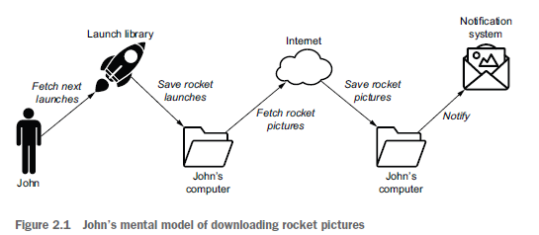

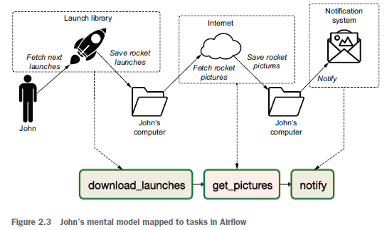

1. **Download_launches**

(mage) C:\data_mgt\mage>mage start spring

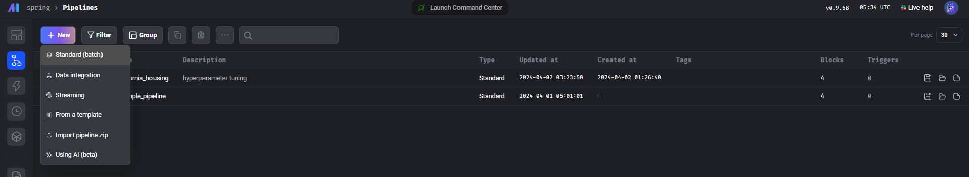

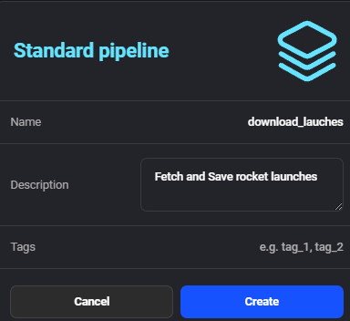

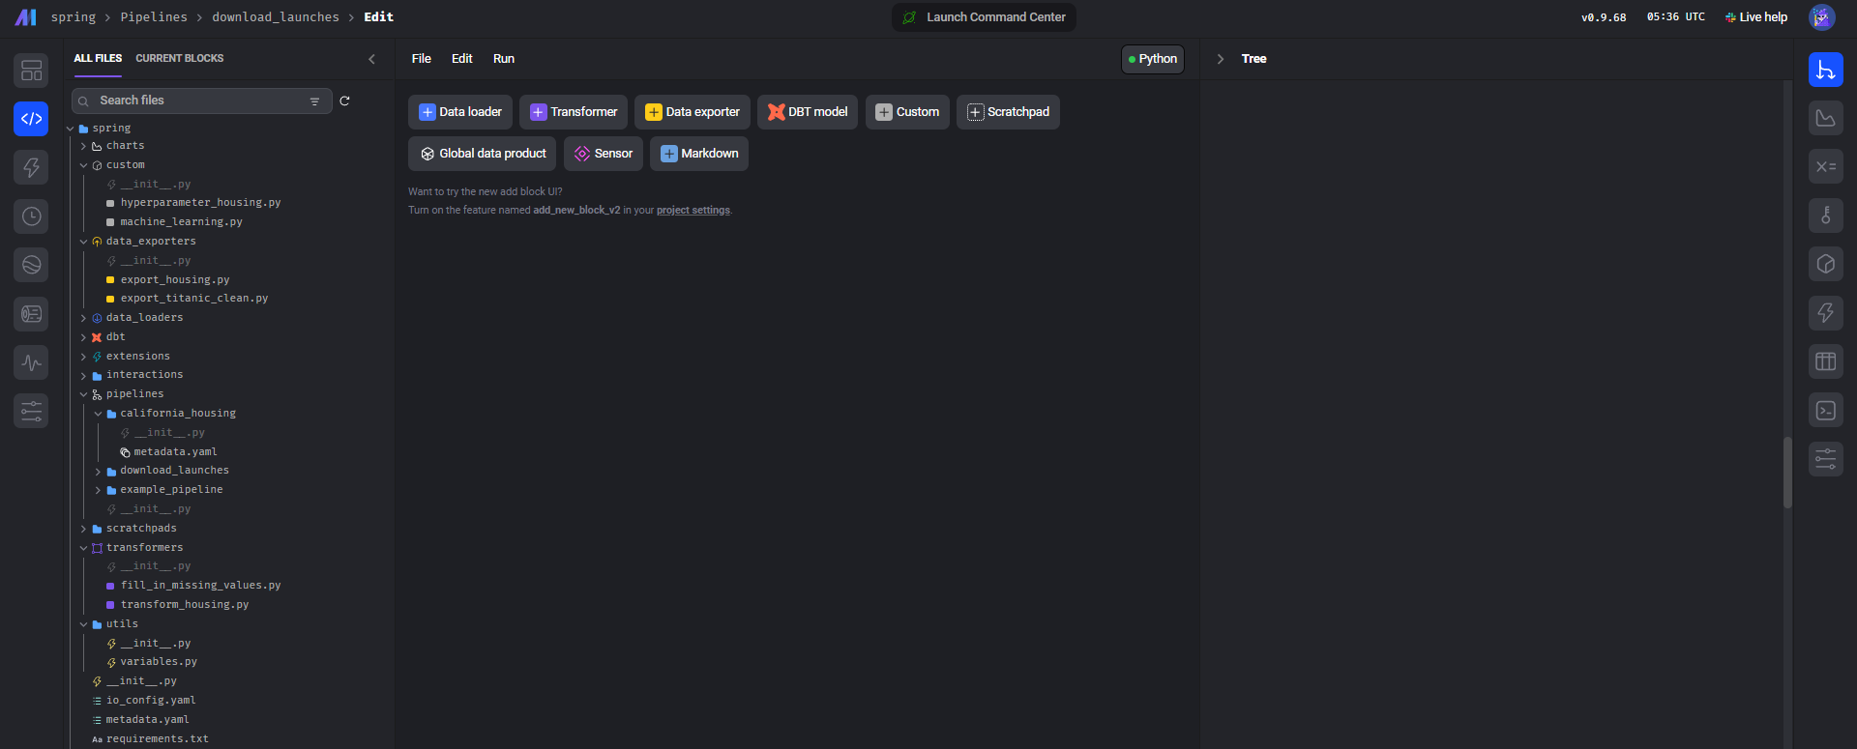

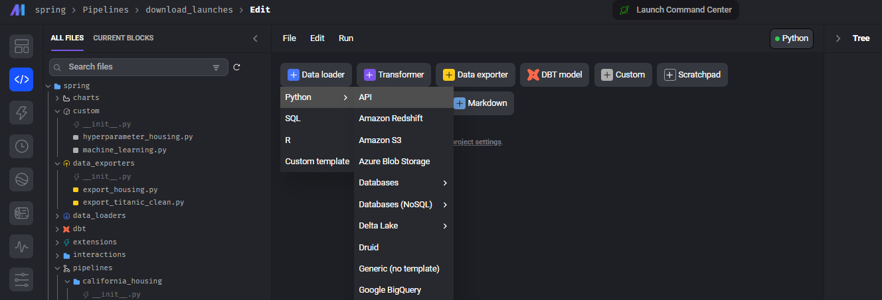

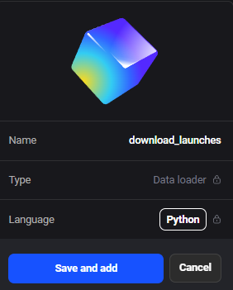

아래 코드 입력하고 Block 실행

import io

import pandas as pd

import requests

import os

if 'data_loader' not in globals():

    from mage_ai.data_preparation.decorators import data_loader

if 'test' not in globals():

    from mage_ai.data_preparation.decorators import test

@data_loader

def load_data_from_api(*args, **kwargs):

    url = 'https://ll.thespacedevs.com/2.0.0/launch/upcoming'

*#C:\python\etl\mage\spellbound\data_loaders*

*#../../*

    os.makedirs("../data", exist_ok=True)  *# mage folder 아래 rocket folder 생성*

    response = requests.get(url)

    with open("../data/launches.json", "wb") as f:

        f.write(response.content)

*# Assuming the API returns a JSON that can be read into a DataFrame*

    data = response.json()

    return pd.DataFrame(data)

@test

def test_output(output, *args) -> None:

    """

    Template code for testing the output of the block.

    """

    assert output is not None, 'The output is undefined'

1. **Transform_rocket_launches**

Click Transformer 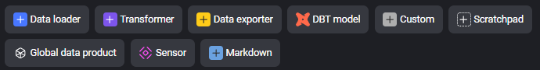

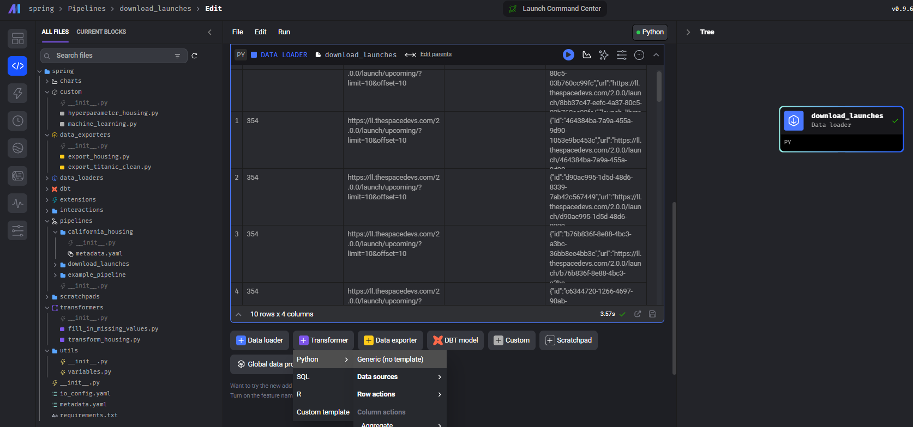

import json

import requests

import requests.exceptions as requests_exceptions

import os

if 'transformer' not in globals():

    from mage_ai.data_preparation.decorators import transformer

if 'test' not in globals():

    from mage_ai.data_preparation.decorators import test

@transformer

def get_pictures(data, *args, **kwargs):

    os.makedirs(f"../image", exist_ok=True)

*# Explicitly set the encoding to 'utf-8'*

    with open("../data/launches.json", encoding='utf-8') as f:

        launches = json.load(f)

    image_urls = [launch["image"] for launch in launches["results"]]

    print(image_urls)

    for image_url in image_urls:

        try:

            response = requests.get(image_url)

            image_filename = image_url.split("/")[-1]

*# Fix the target file path*

            target_file = os.path.join("../image", image_filename)

            with open(target_file, "wb") as f:

                f.write(response.content)

            print(f"Downloaded {image_url} to {target_file}")

        except requests_exceptions.MissingSchema:

            print(f"{image_url} appears to be an invalid URL.")

        except requests_exceptions.ConnectionError:

            print(f"Could not connect to {image_url}.")

    return data

@test

def test_output(output, *args) -> None:

    """

    Template code for testing the output of the block.

    """

    assert output is not None, 'The output is undefined'

Block 실행

1. **Export_rocket_launches**

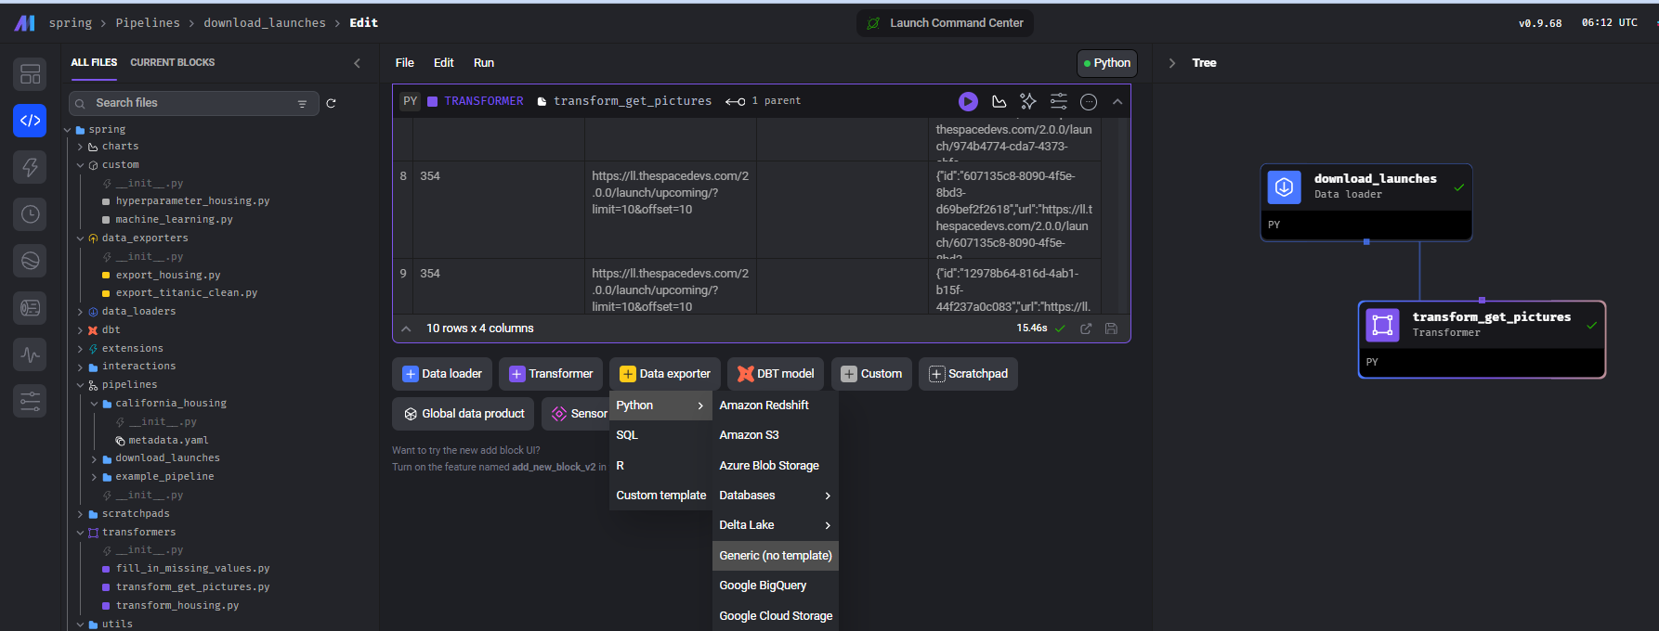

아래 코드 입력하고 block 실행

import os

if 'data_exporter' not in globals():

    from mage_ai.data_preparation.decorators import data_exporter

@data_exporter

def notify(*args, **kwargs):

    images_count = len(os.listdir("../image"))

    if images_count > 0:

        print(f"There are now {images_count} images.")

    else :

        print("No images downloaded")

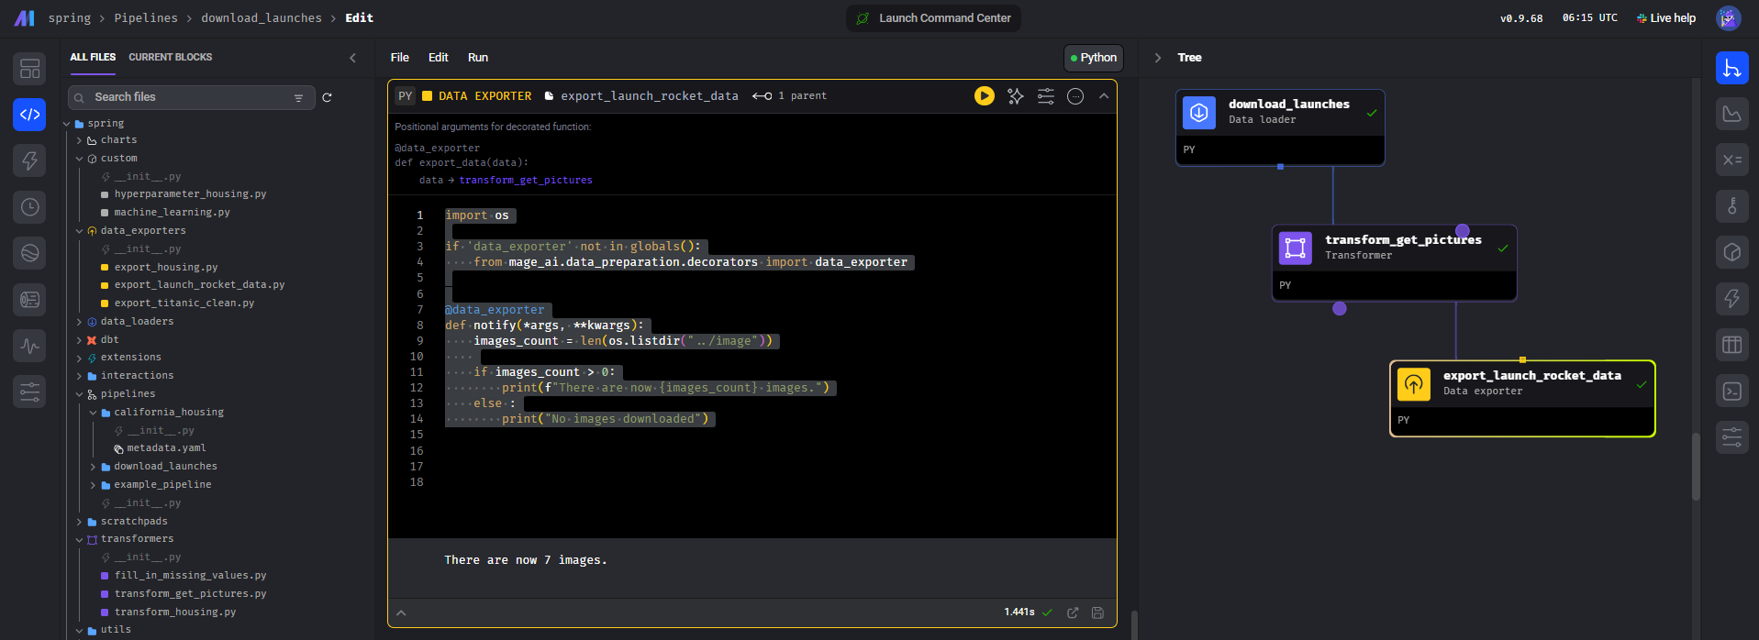

1. **Review**

왼쪽 상단의 메뉴 spring > Pipeline을 클릭하면

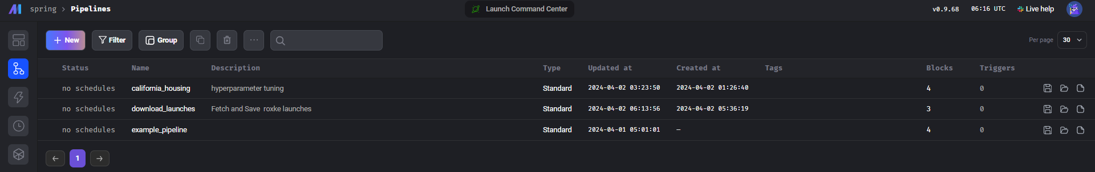

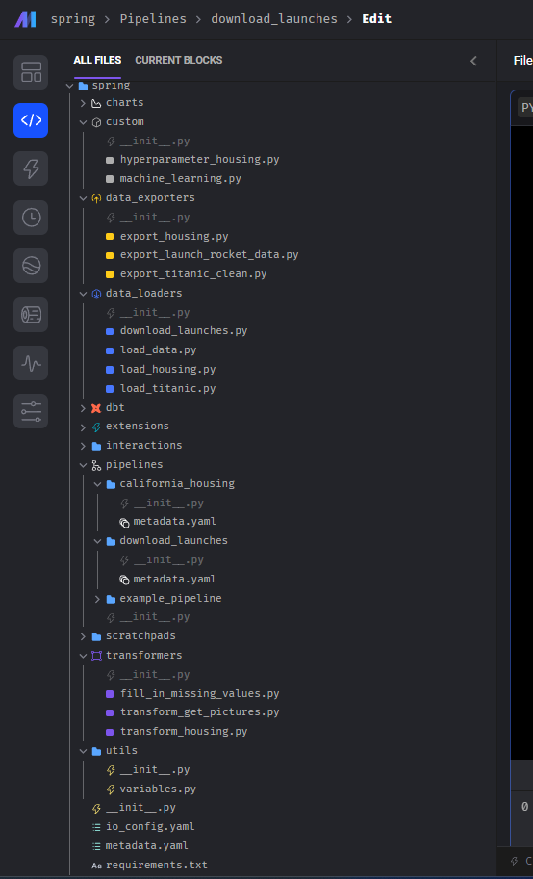

VS code에서 확인 (여기서 *py 파일 편집이 가능)

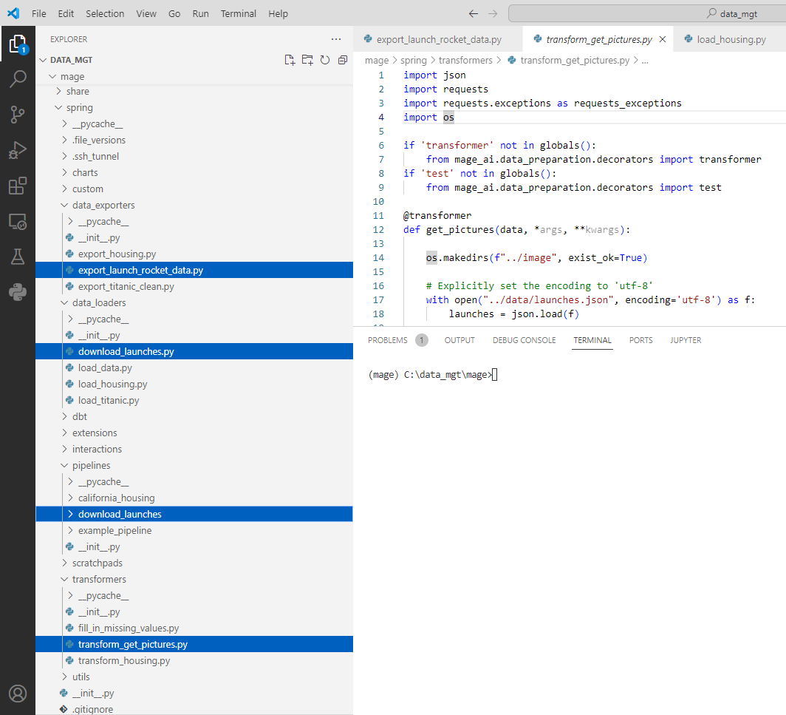

현재 폴더는 (mage) C:\data_mgt\mage> 🡪 mage

‘../image’, ‘../data’ 상대적 폴더 위치에서 디렉토리를 만들었기 때문에

os.makedirs("../data", exist_ok=True)  # mage folder 아래로 data folder 생성

1. **Restart**

**. Mage WEB ui close**

**. Vs code에서 “ctrl + c”로 stop**

**.**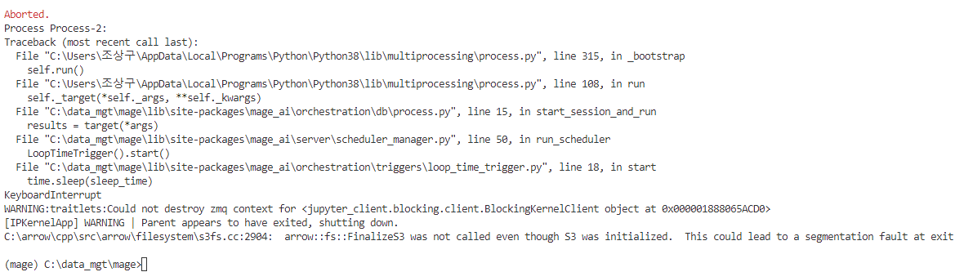

**가상환경에서 Spring 프로젝트가 있는 상위 폴더에서 mage start**

**. (mage) C:\data_mgt\mage>**

**. (mage) C:\data_mgt\mage>mage start spring**

**. No**

**. (mage) C:\data_mgt\>mage start spring**